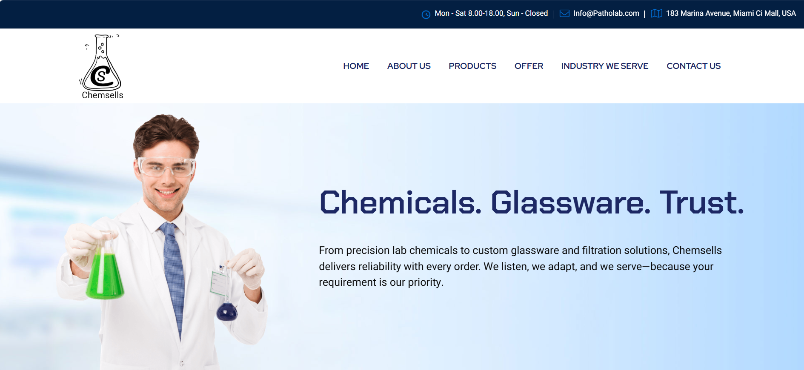

Correction is below
Logo top left ma che ene thodo nano karo
Uppar menu bar che ( home abou us vegere ene thodu left ma rakho ama logo ekdam alag thai padto lage che
Chemicals. Glassware. Trust ne replace kari ne – Fine Chemicals & Lab ware Supplier.
Content ( content na baju ma je manas nu imabge che ena badle chemical nu image rakhvu padse koi hamda blank rakhso to chalse)
Chemsells is a leading supplier of Fine chemicals & Lab chemicals serving the Speciality, pharmaceutical, Agriculture, Cosmetics, Food & Beverages many more industries.
We offered diversified product range include Laboratory Chemicals, Laboratory glassware, Filtration products & Plasticwares.


Correction is below
3 years remove kari nakho
Hu chemical na pic moklu chu ee upload kari dejo ee hexagone thodu motu kari ne.

Right Side Wado Content
About Us
Welcome to Chemsells your trusted global partner in laboratory and fine chemicals.
With a strong commitment to quality and innovation, we specialize in the supply of fine chemicals, analytical reagents, HPLC solvents, bio-chemicals, molecular biology chemicals, Karl Fischer reagents & other high-purity specialty chemicals. Whether you are in research and development, pharmaceuticals, cosmetics, paints & pigments, electronics, or other industrial sectors, our products are designed to meet your requirements.
We Offer
lab chemicals : Including high-purity fine chemicals, analytical reagents, Lab reagents, solvents, and custom blends for specialized applications.
Lab Glassware & Plasticware : A wide range of durable and precise laboratory glassware and plasticwares for Laboratory & industry professional use.
Filtration Products : Trusted solutions for critical filtration processes in lab and industrial environments.
Specialty Chemicals : Including Karl Fischer reagents, HPLC-grade solvents, and molecular biological chemicals tailored for specific applications.
Why Choose Us?
- High-quality, lab-grade chemicals and Labware’s
- Competitive pricing and bulk supply options
- Prompt international shipping and customer support
- Custom sourcing and neutral labelling available

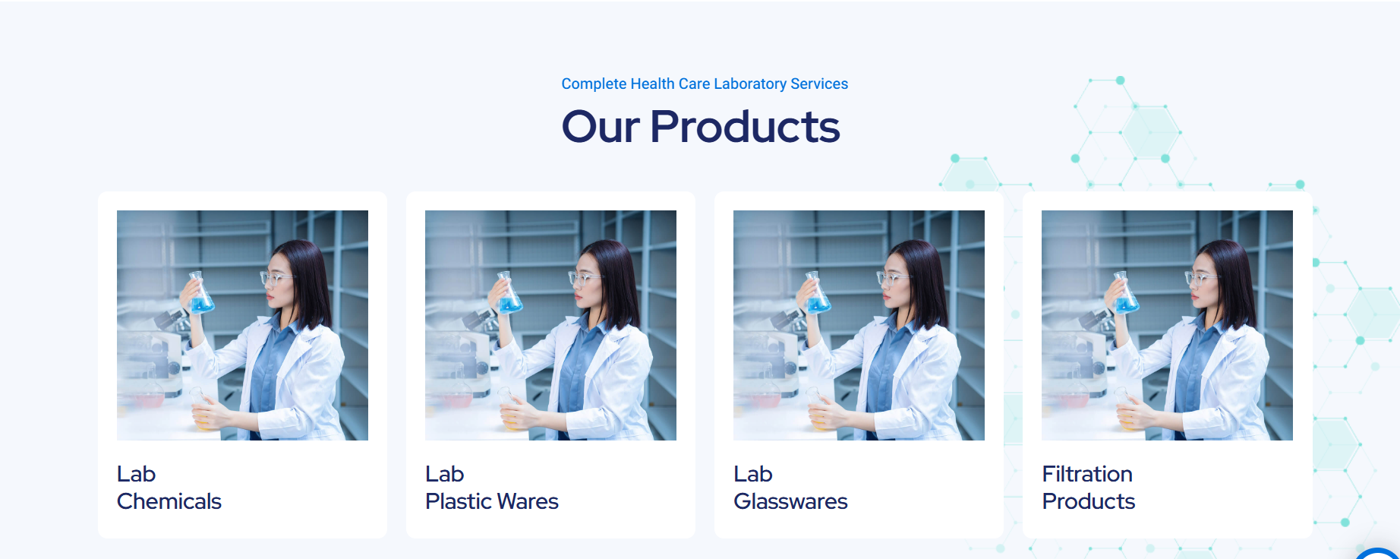

Heading Our Products rakho eni uppar kai nai lakho
Aa 4 e images che ema ya niche lab chemicals lakhyu che ema click karye to separate page open thai evu link rakho.

Last ma employment form che ena badle inquiry form nakhi dov

